EXTRA LAB
1.3) Create a database called library_db and a table books with columns: book_id,title, author, publisher,year_of_publication,andprice.Insert five records into
the table
CREATE DATABASE library_db;
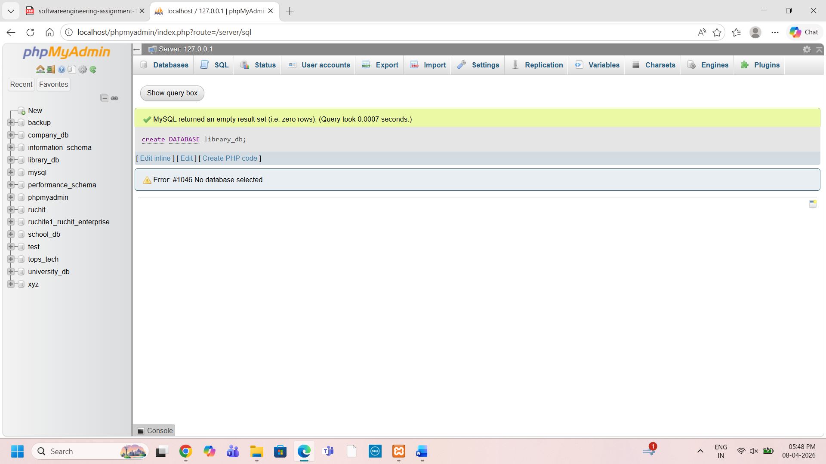
Create table:
CREATE TABLE books (
book_id INT PRIMARY KEY,
title VARCHAR(100),
author VARCHAR(100),
publisher VARCHAR(100),
year_of_publication INT,
price DECIMAL(10,2)
);
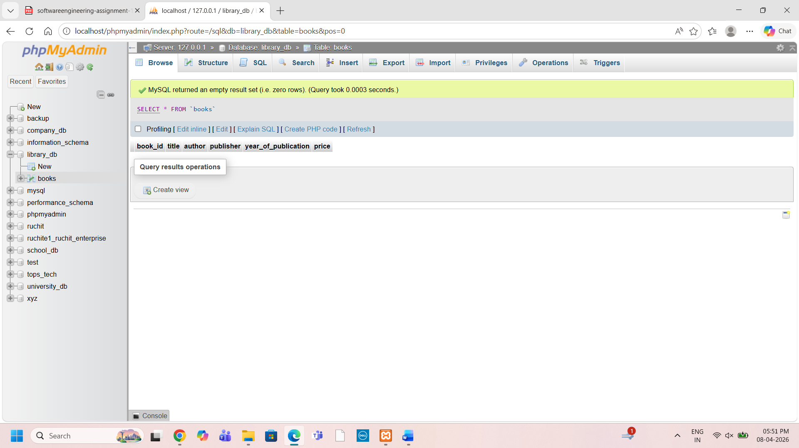
Insert records:
INSERT INTO books (title, author, publisher, year_of_publication, price) VALUES
('C Programming', 'Dennis Ritchie', 'Prentice Hall', 1988, 450.50),
('Java Programming', 'James Gosling', 'Sun Microsystems', 1995, 550.00),
('Python Basics', 'Guido van Rossum', 'O Reilly', 2000, 600.75),
('Data Structures', 'Mark Allen Weiss', 'Pearson', 2012, 700.00),
('Operating System', 'Galvin', 'Wiley', 2015, 650.25);
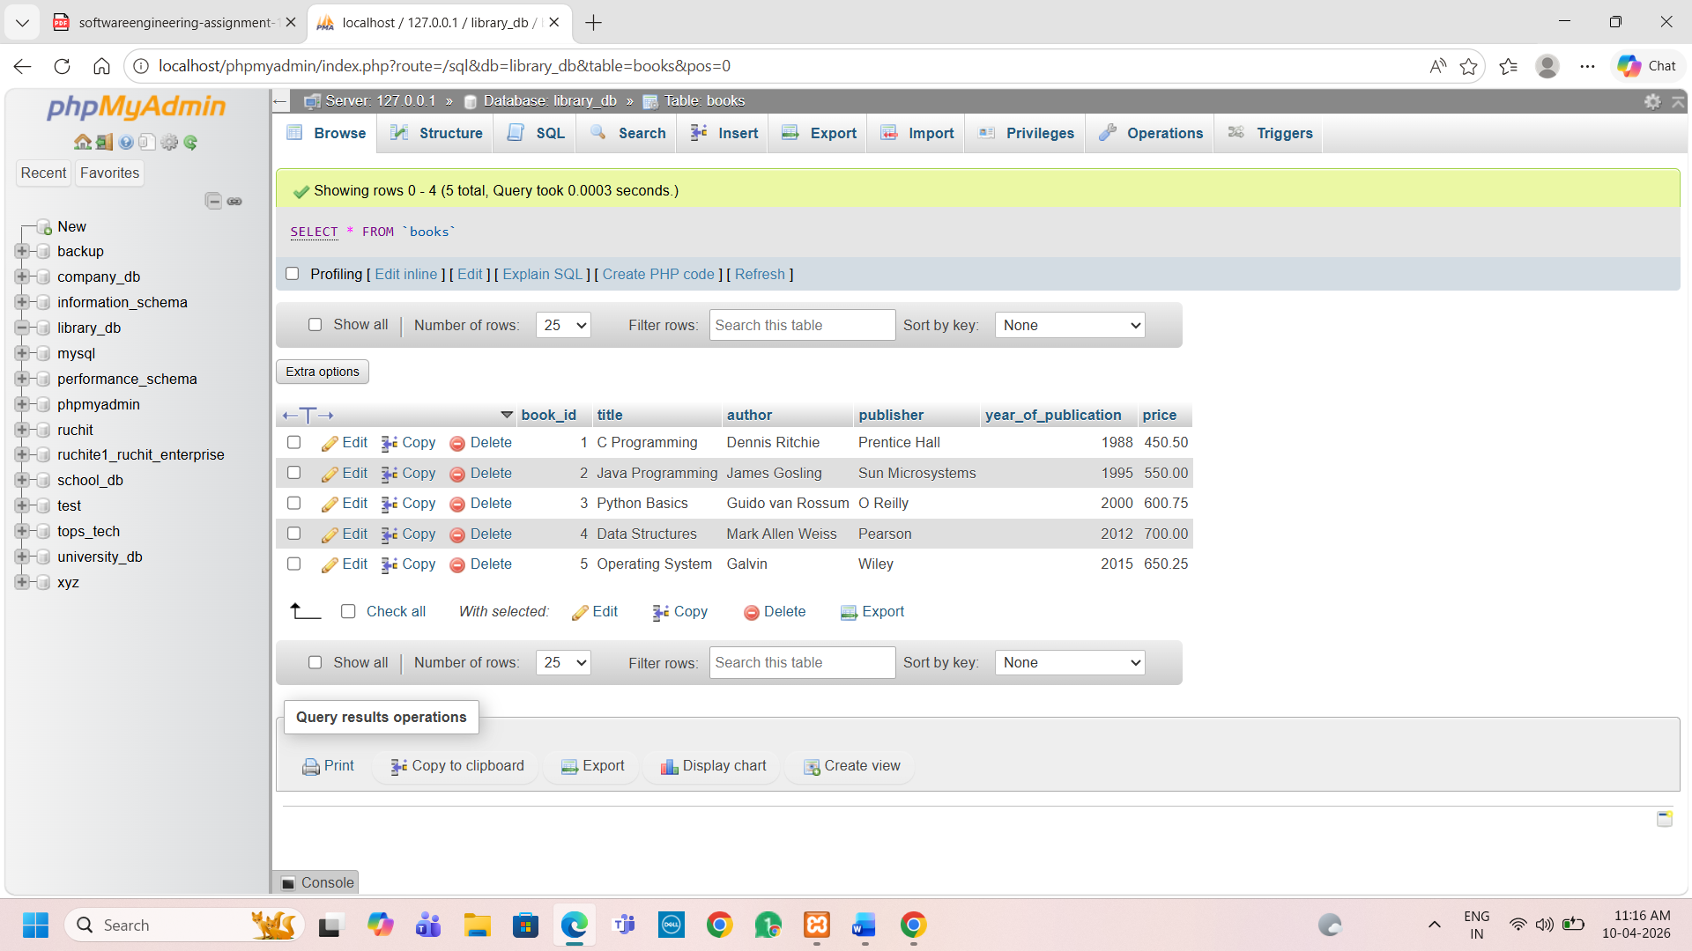
1.4) Create a table members in library_db with columns: member_id, member_name, date_of_membership, and email. Insert five records into this table.
create table members (member_id int PRIMARY key AUTO_INCREMENT,member_name varchar(50),date_of_membership int ,email varchar(50));
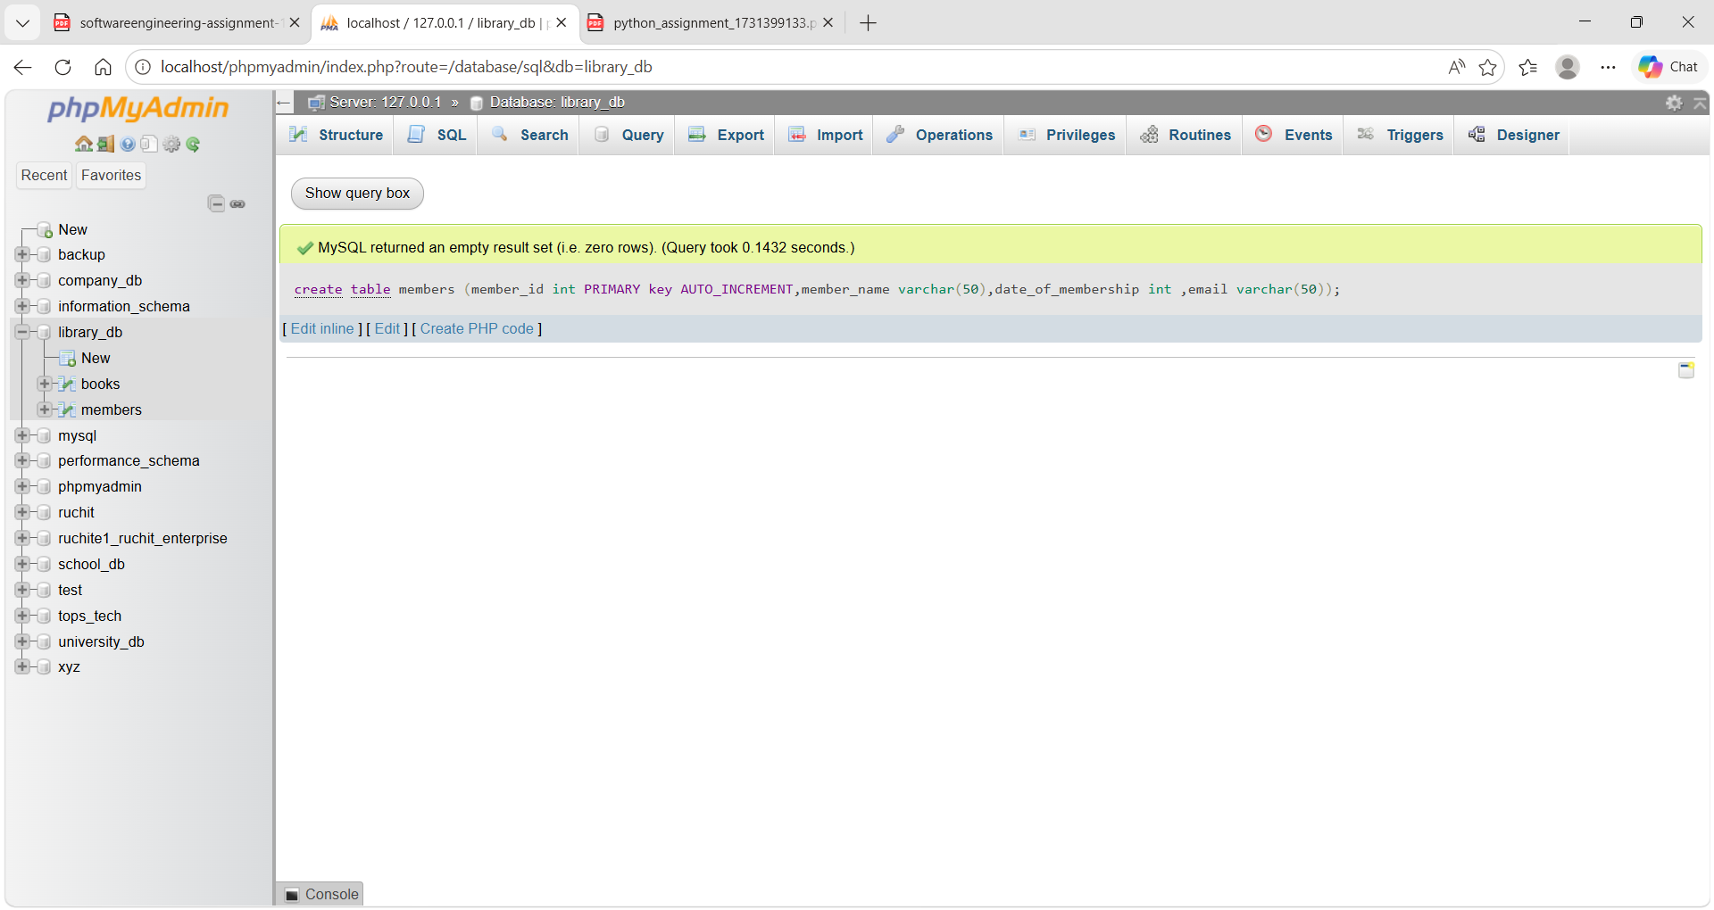
Insert data:
INSERT INTO members (member_name, date_of_membership, email) VALUES
('Amit Shah', 2020, 'amit@gmail.com'),
('Priya Patel', 2021, 'priya@gmail.com'),
('Rahul Mehta', 2019, 'rahul@gmail.com'),
('Neha Joshi', 2022, 'neha@gmail.com'),
('Karan Desai', 2023, 'karan@gmail.com');
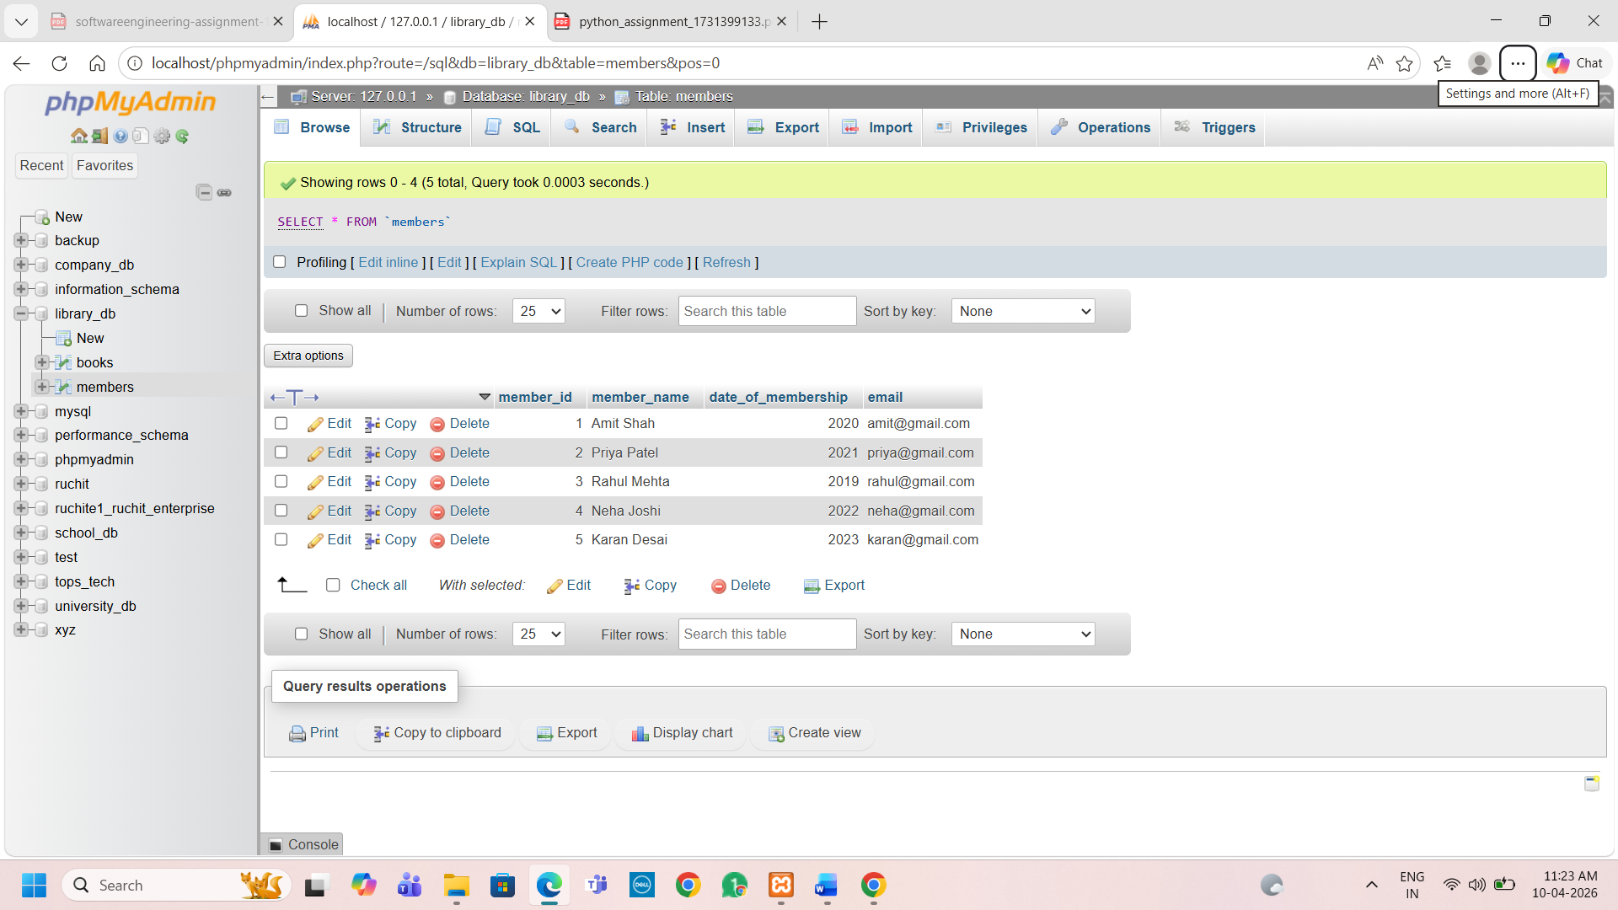
2.3) Retrieve all members who joined the library before 2022. Use appropriate SQL syntax with WHERE and ORDER BY.
select * from members where date_of_membership<2022 order by date_of_membership;
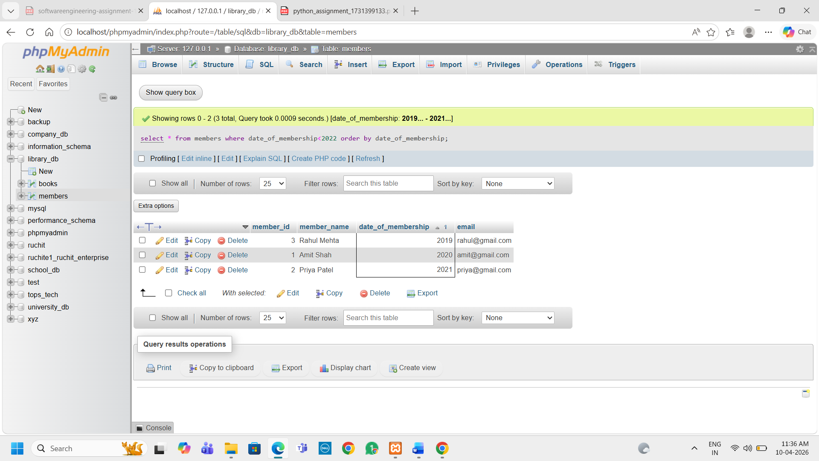
2.4) Write SQL queries to display the titles of books published by a specific author. Sort the results by year_of_publication in descending order.
4.3)Create a table authors with the following columns: author_id, first_name, last_name, and country. Set author_id as the primary key.
CREATE TABLE authors (
author_id INT PRIMARY KEY,
first_name VARCHAR(50),
last_name VARCHAR(50),
country VARCHAR(50)
);
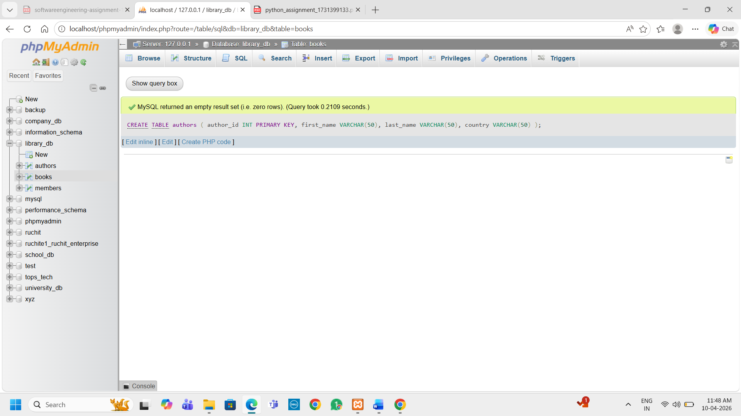
4.4)Create a table publishers with columns: publisher_id, publisher_name, contact_number, and address. Set publisher_id as the primary key and contact_number as unique.
CREATE TABLE publishers (
publisher_id INT PRIMARY KEY, publisher_name VARCHAR(100),
contact_number VARCHAR(15) UNIQUE,
address VARCHAR(150));
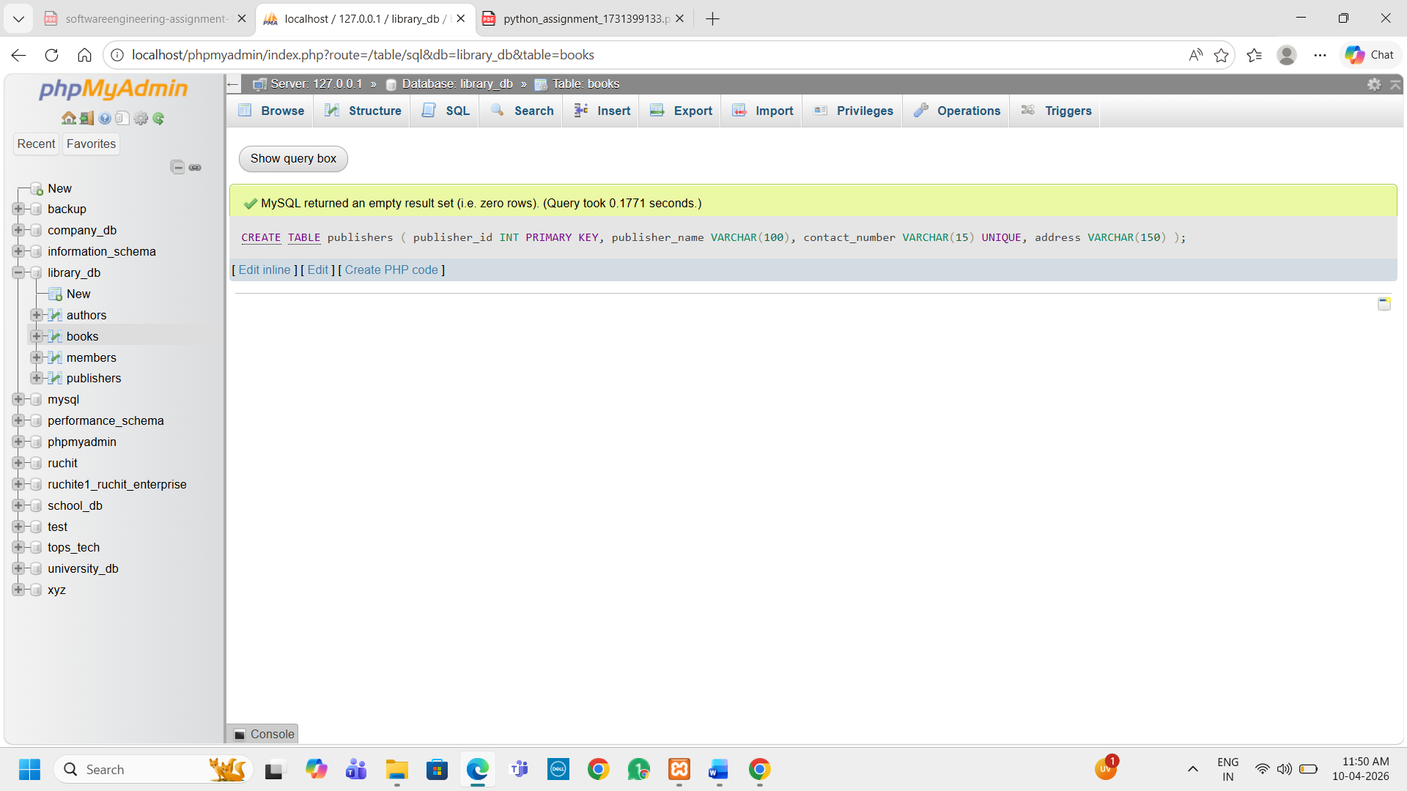
5.3) Add a new column genre to the books table. Update the genre for all existing records.
ALTER TABLE books
ADD genre VARCHAR(50);
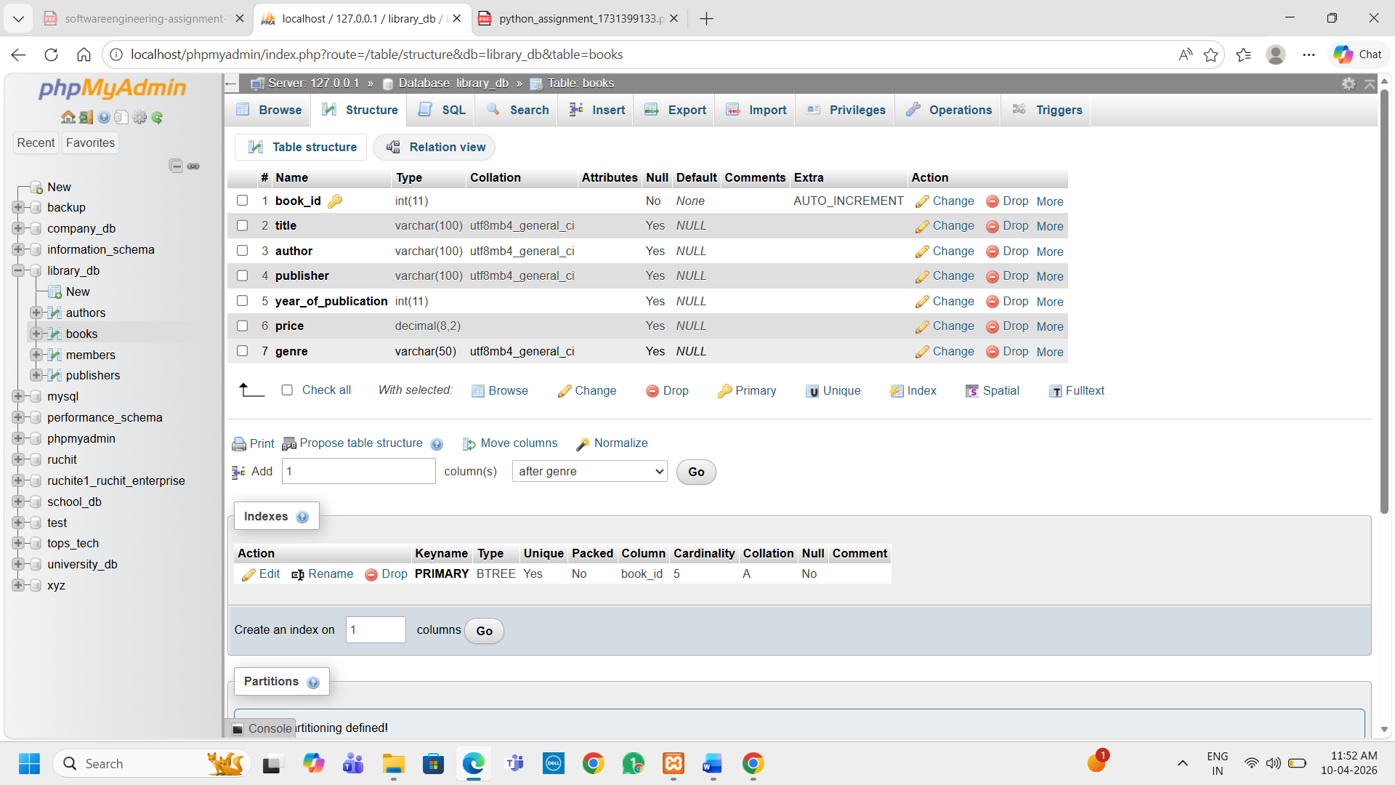
UPDATE books
SET genre = 'Programming';
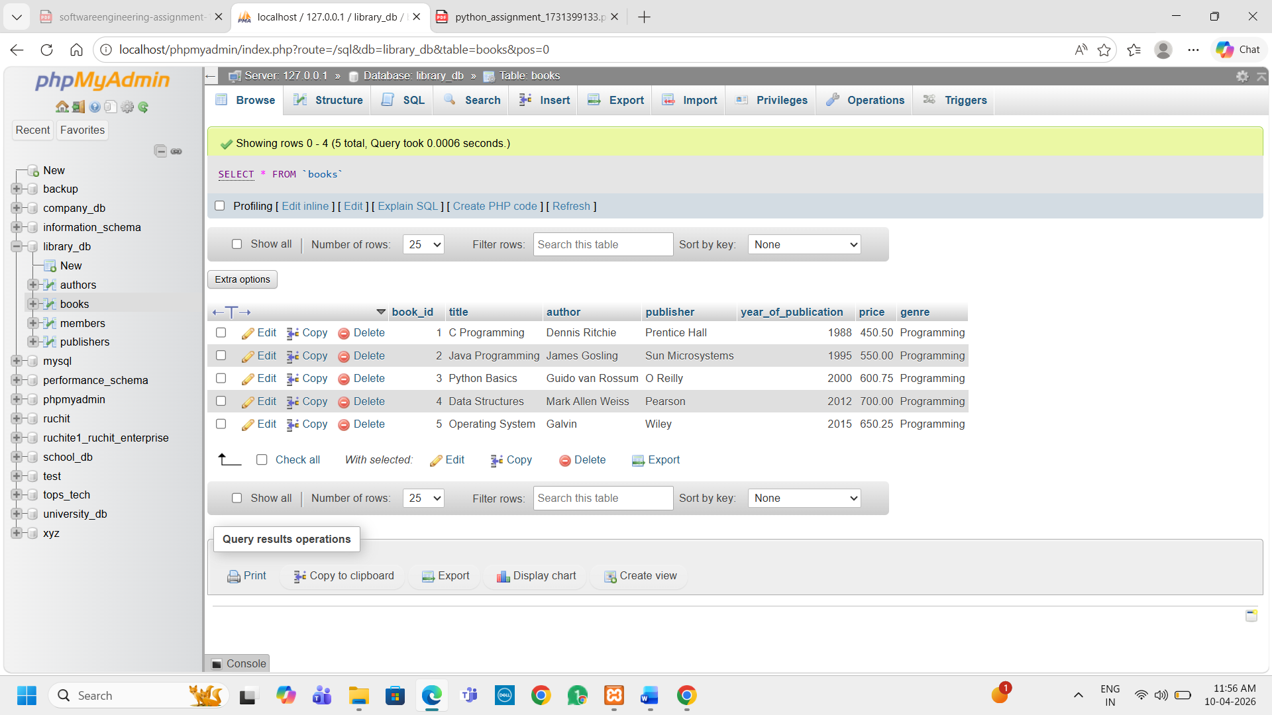
5.4) Modify the members table to increase the length of the email column to 100 characters.
ALTER TABLE members
MODIFY email VARCHAR(100);
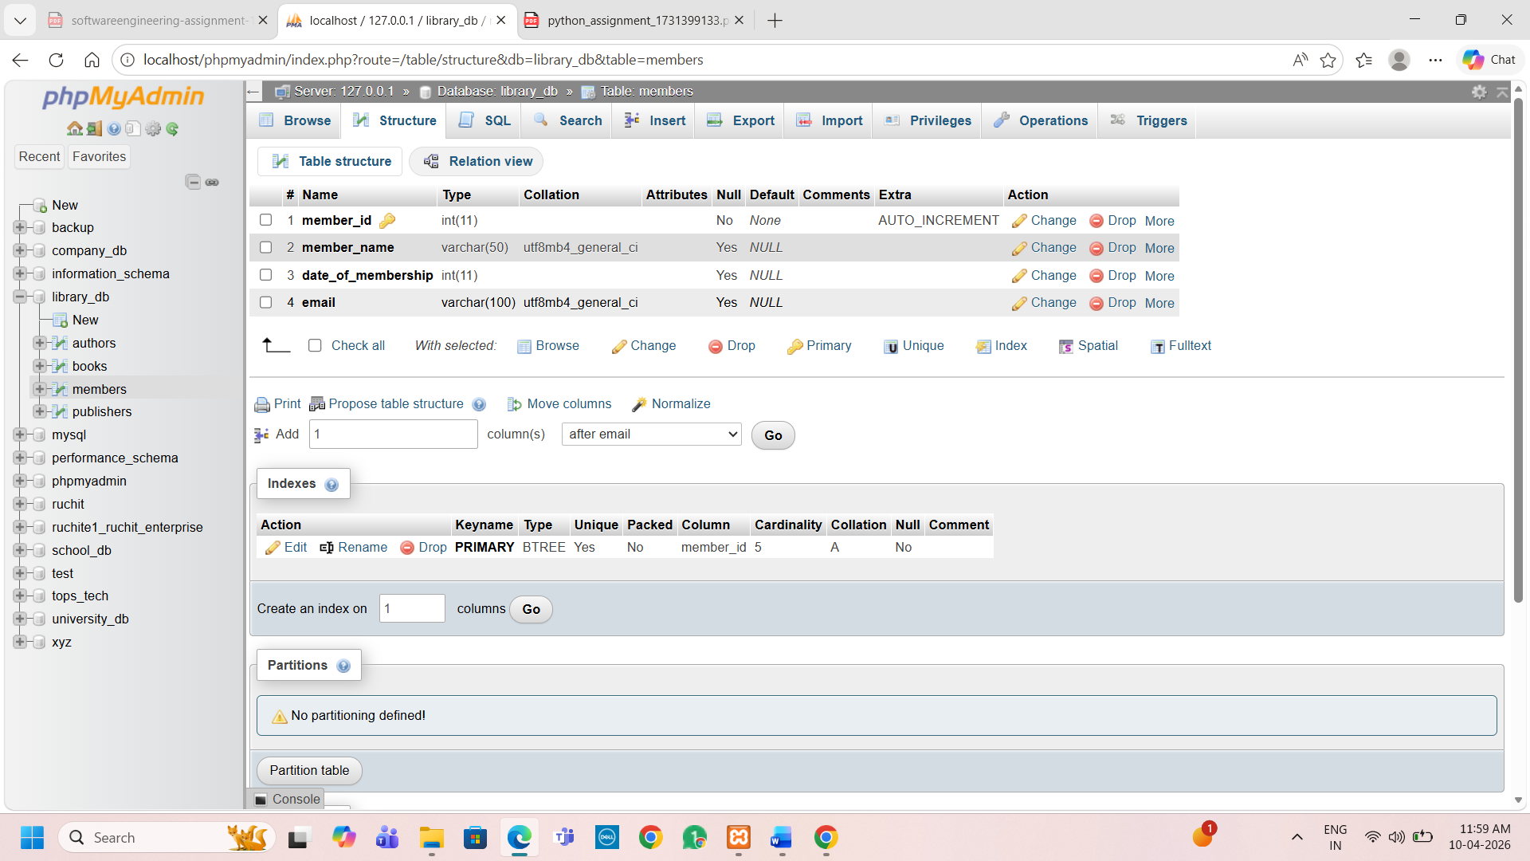
6.3) Drop the publishers table from the database after verifying its structure.
1. Verify table structure
DESCRIBE publishers;
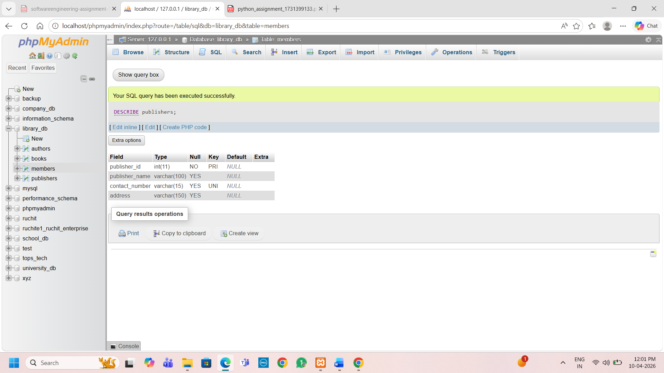
DROP TABLE publishers;
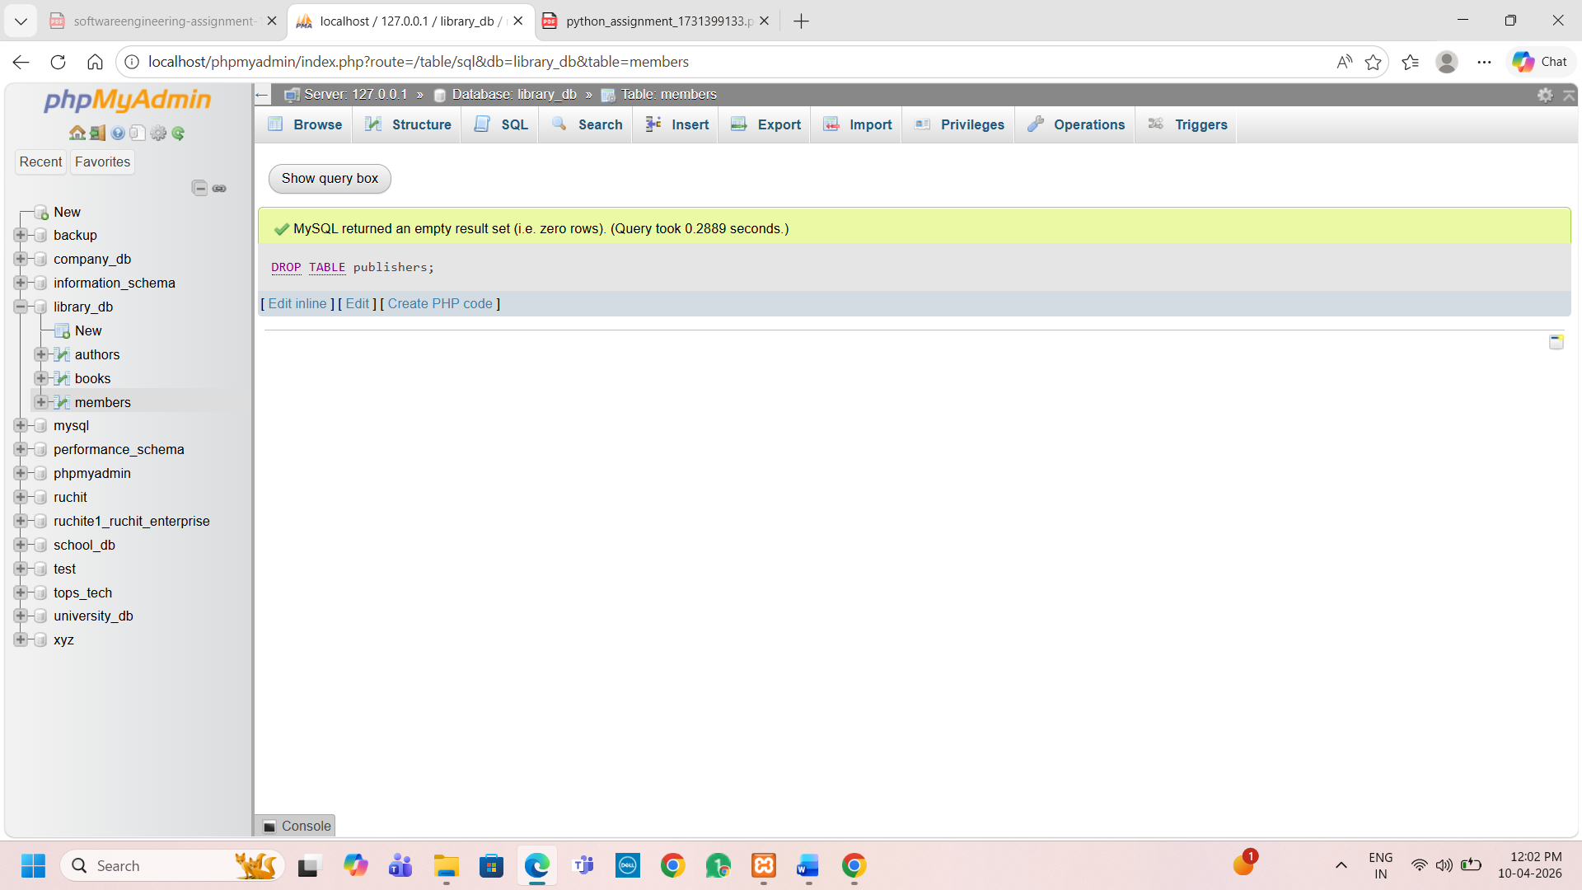
6.4)Create a backup of the members table and then drop the original members table.
CREATE TABLE members_backup AS SELECT * FROM members;
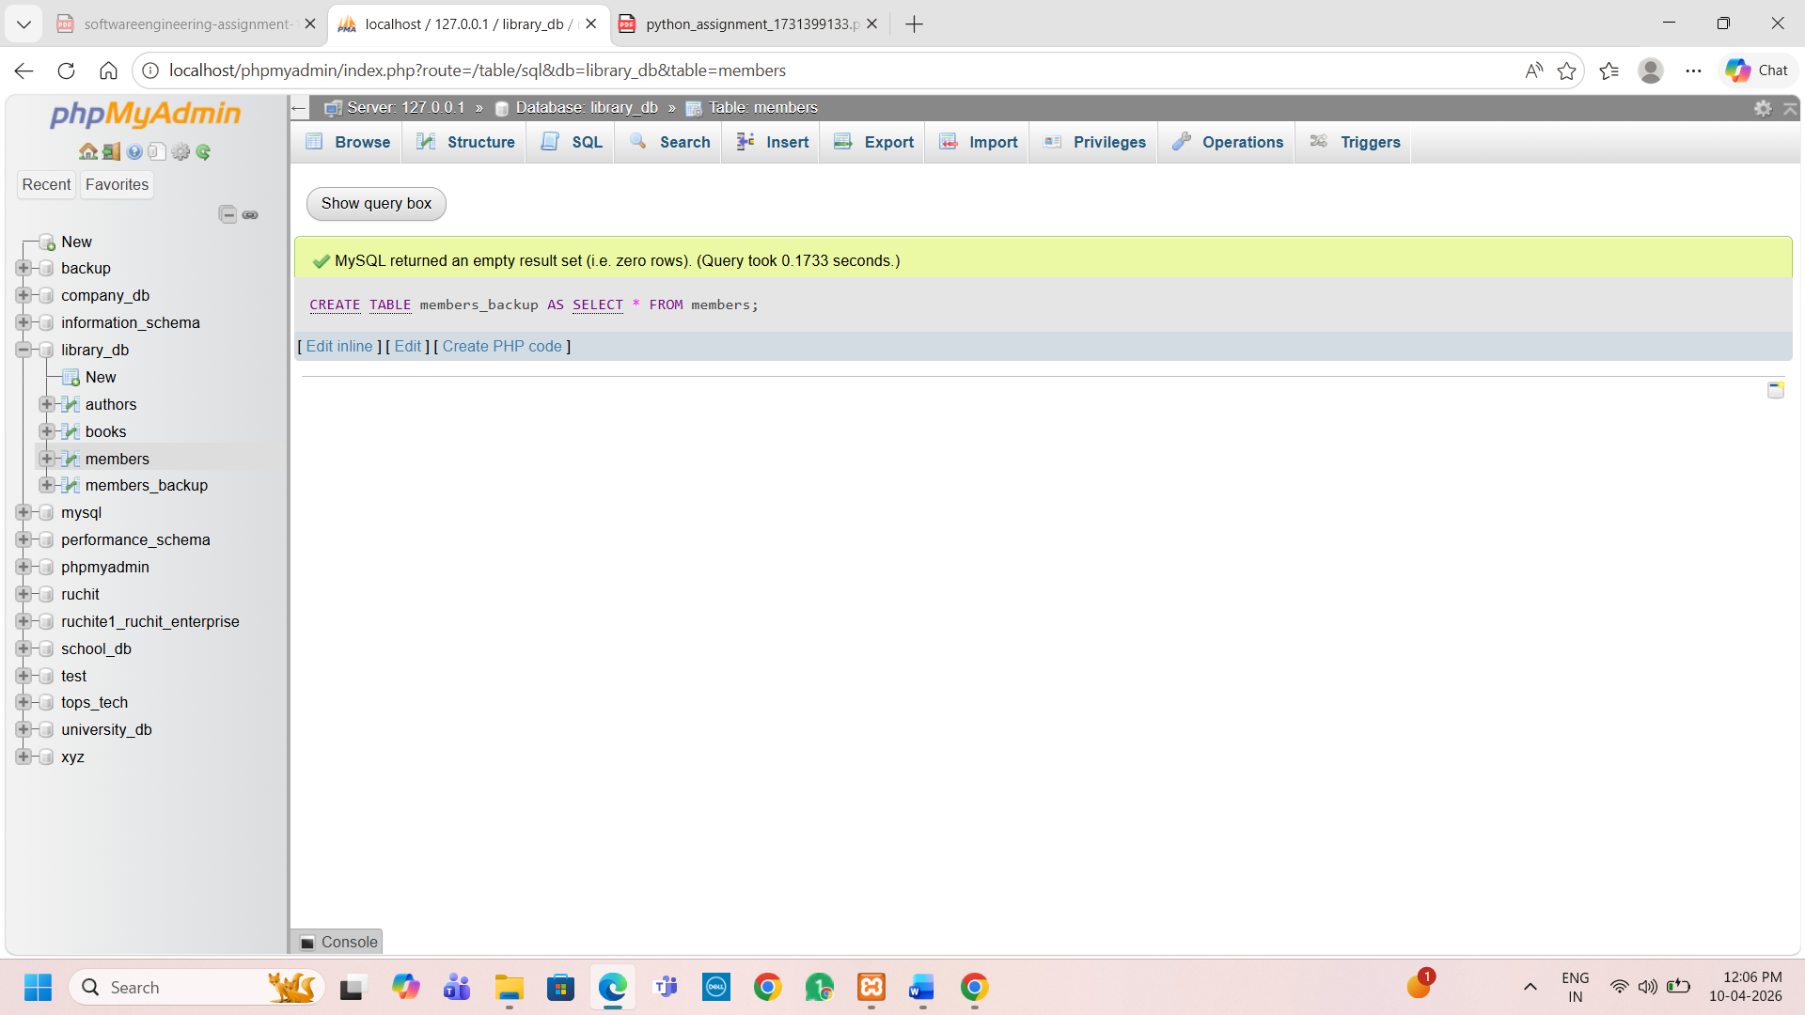
Drop table members;
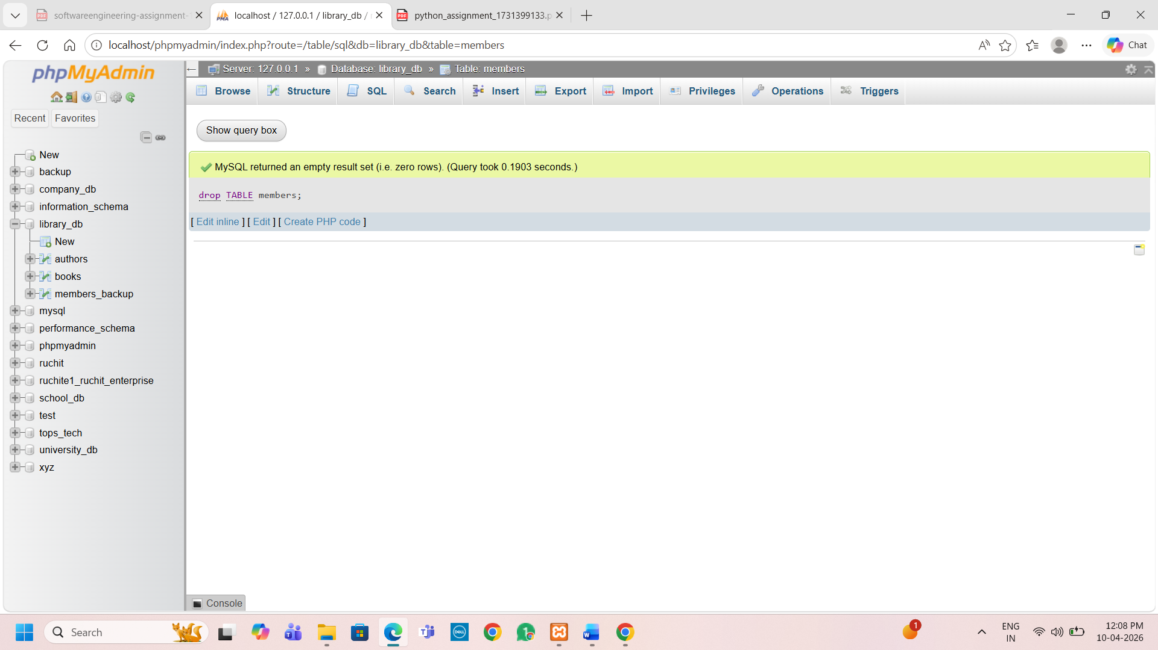
7.4) Insert three new authors into the authors table, then update the last name of one of the authors.
INSERT INTO authors (first_name, last_name, country)
VALUES
('Paulo', 'Coelho', 'Brazil'),
('George', 'Orwell', 'UK'),
('Jane', 'Austen', 'UK');
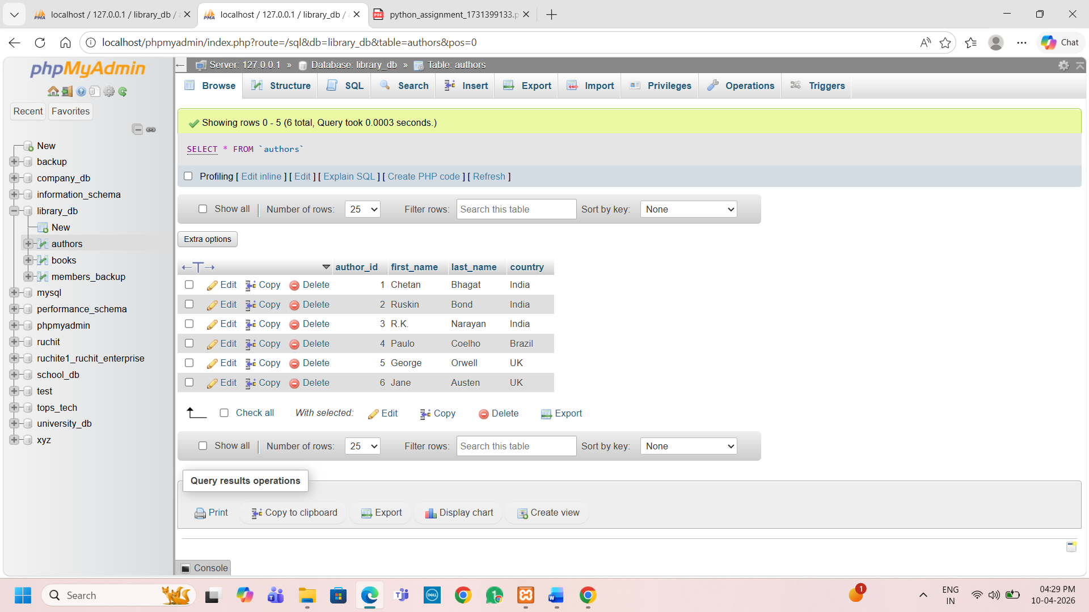
7.5) Delete a book from the books table where the price is higher than $100.
Delete from books where price>100;
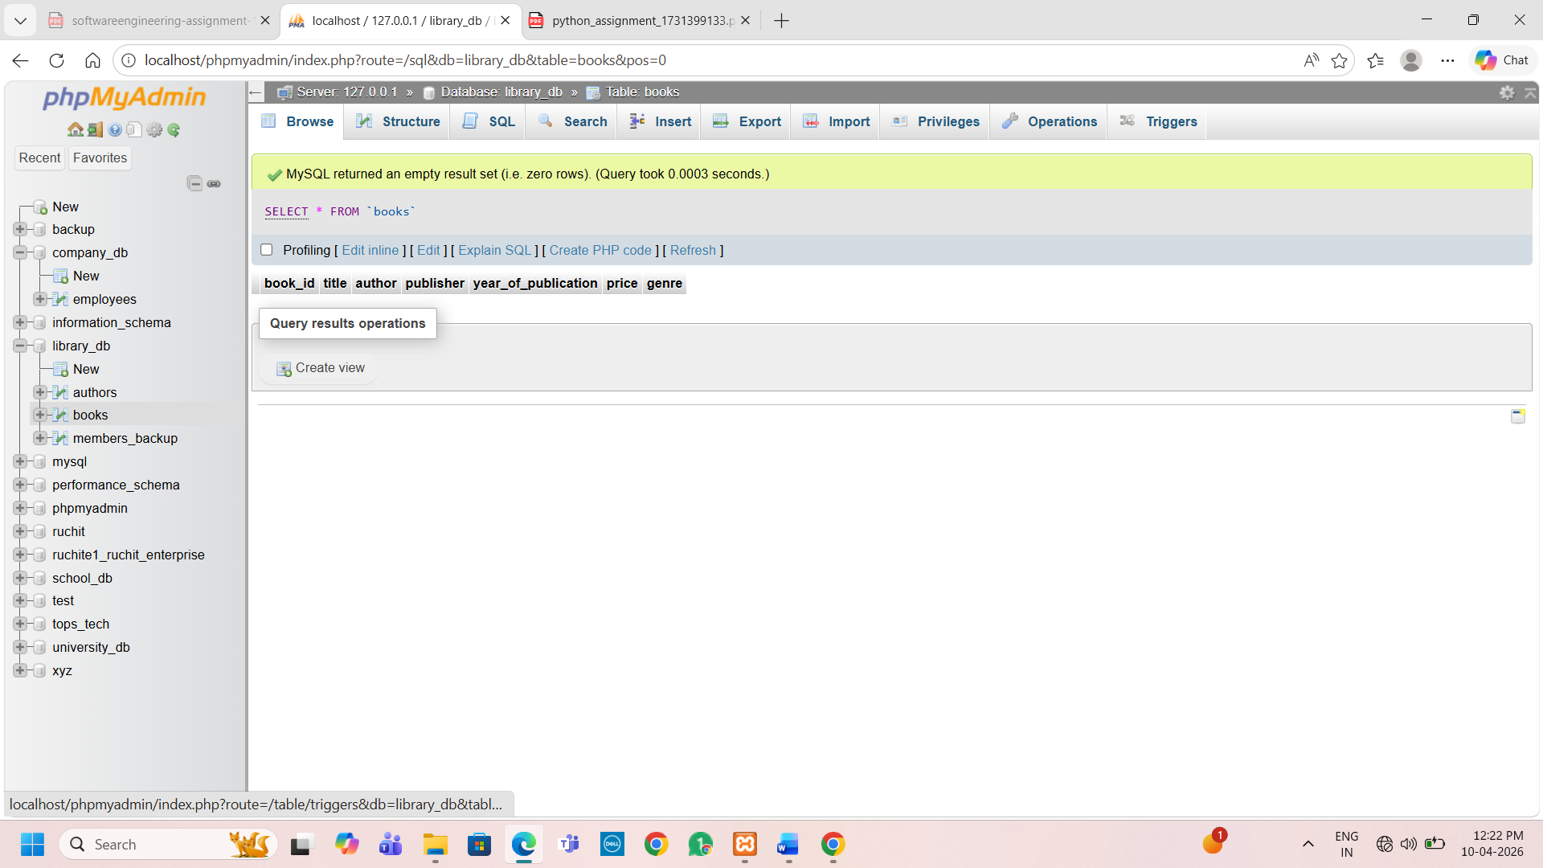
8.3) Update the year_of_publication of a book with a specific book_id.
update books set year_of_publication=2026 where book_id=1
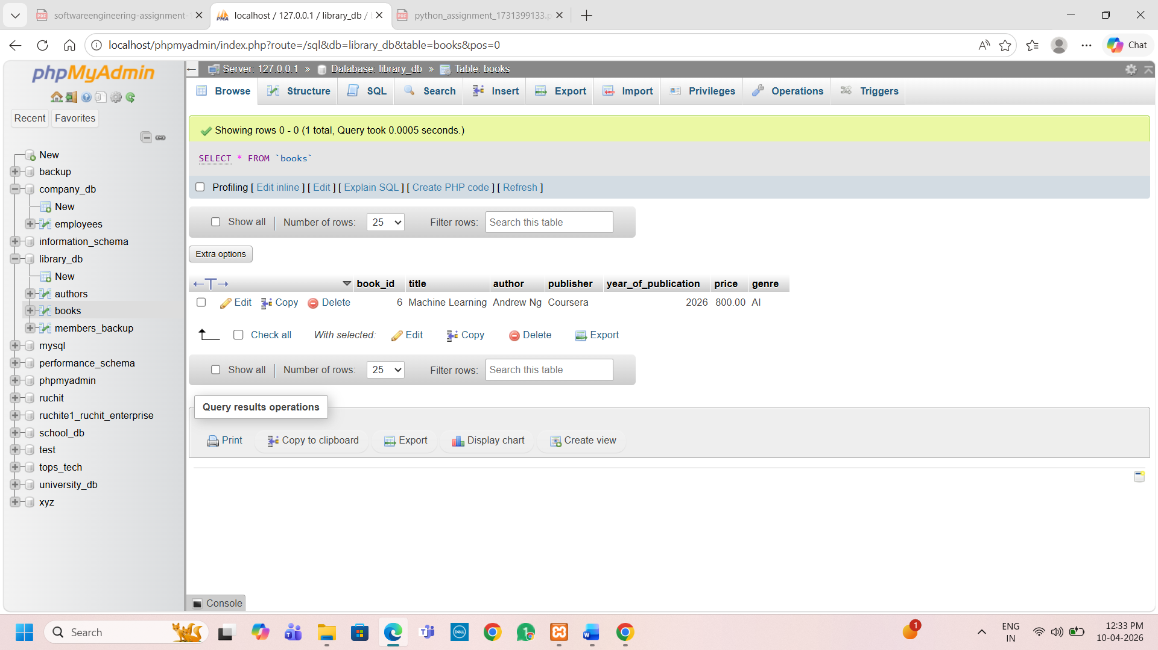
8.4) Increase the price of all books published before 2015 by 10%.
UPDATE books
SET price = price + (price * 0.10) WHERE year_of_publication < 2015;
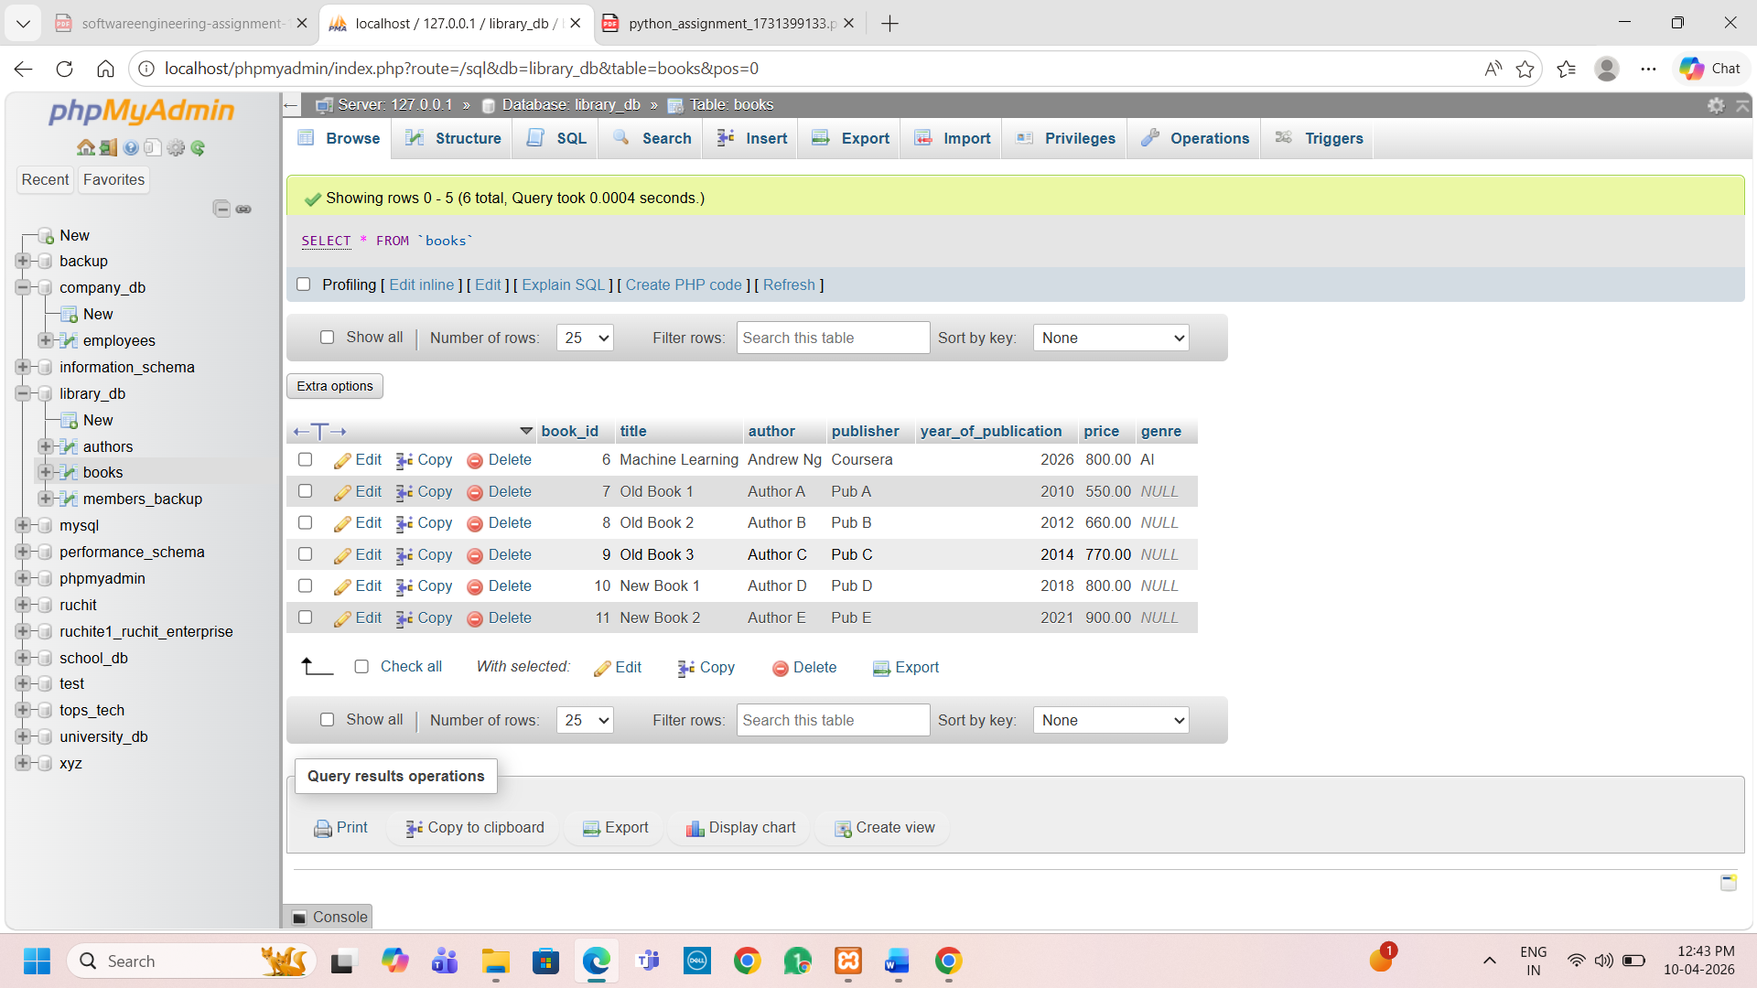
9.3) Remove all members who joined before 2020 from the members table.
DELETE FROM members
WHERE date_of_membership < 2020;
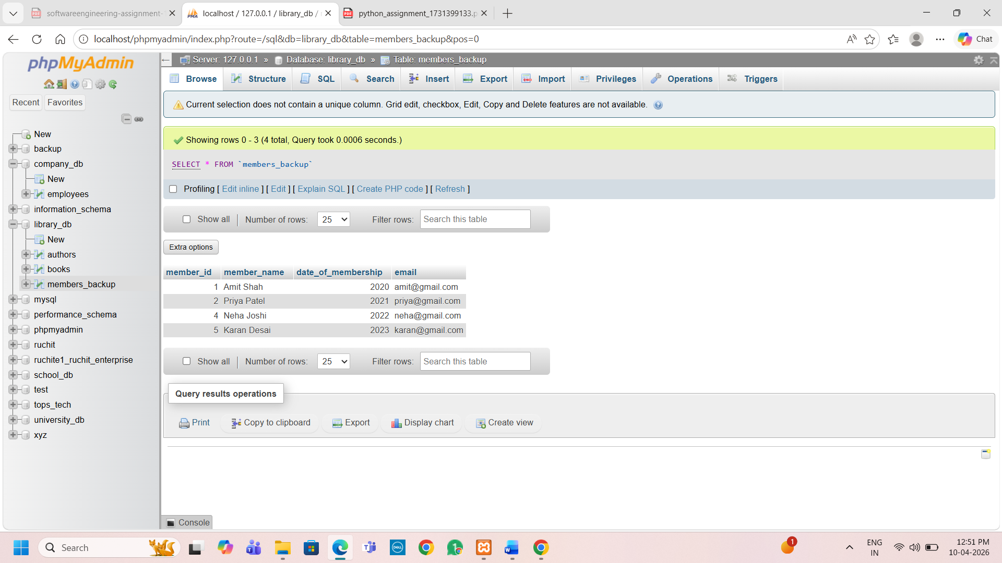
9.4) Increase the price of all books published before 2015 by 10%.
UPDATE books
SET price = price + (price * 0.10)
WHERE year_of_publication < 2015;

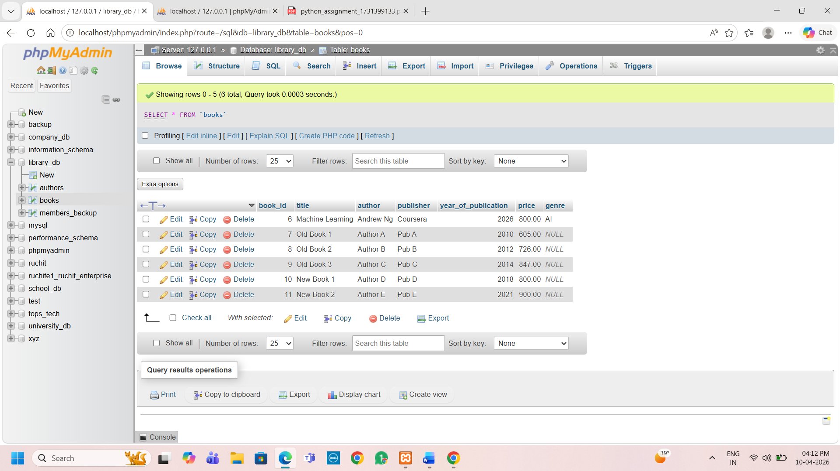
10.4) Write a query to retrieve all books with price between $50 and $100.
Select * from books where price between 50 and 100;
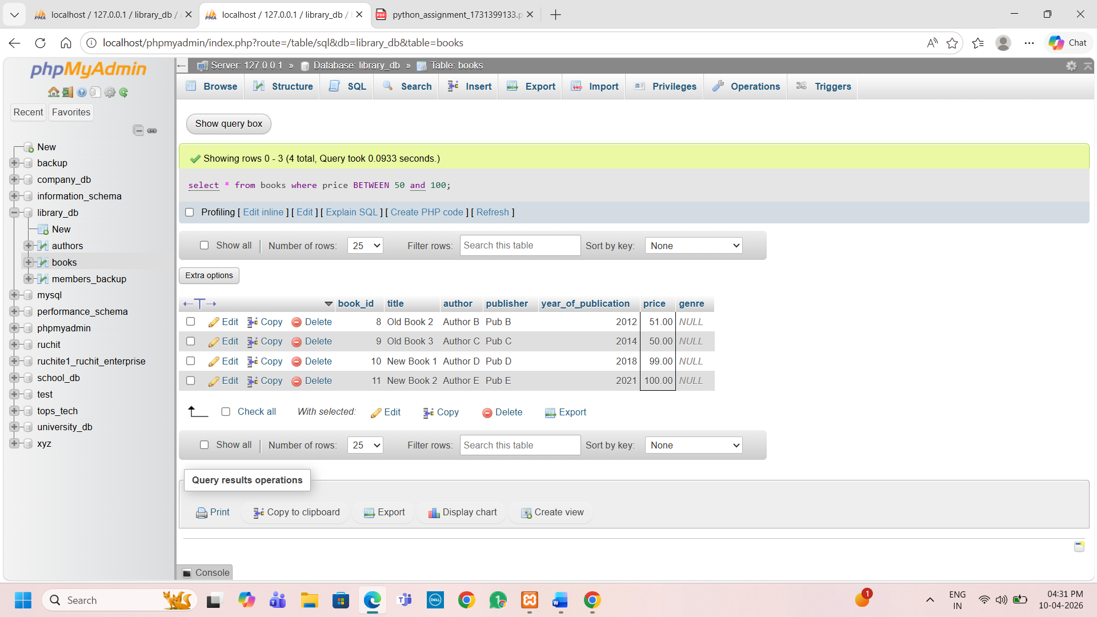
10.5) Retrieve the list of books sorted by author in ascending order and limit the results to the top 3 entries.
SELECT *
FROM books
ORDER BY author ASC
LIMIT 3;
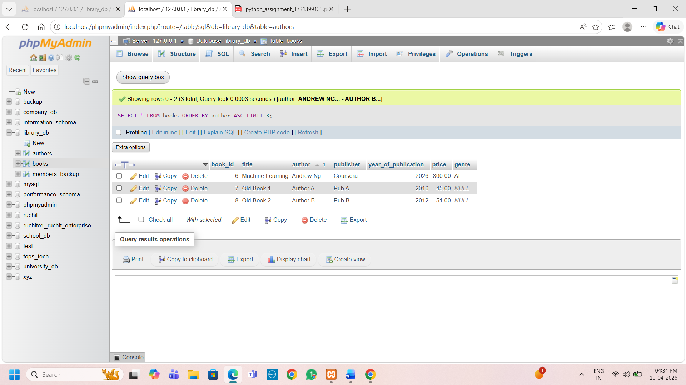
11.3) Grant SELECT permission to a user named librarian on the books table.

